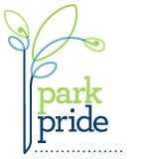
How to Apply for a
Park Pride Matching Grant
The application form on the following pages is a fillable template. You will need MS Word to open and complete this form.
If you do not have MS Word on your computer, or if you have problems, you can download a blank application pdf from our website and complete it by hand, or contact Park Pride at grants@parkpride.org for additional assistance.

Open the application template in Microsoft Word
When you click on the application’s link on our website, the form may open in MS Word or in a browser window (Chrome, Internet Explorer, Firefox, etc.). Do not attempt to complete the application in the browser window (or on your phone or tablet), you must open the form in MS Word.

If the form opens in your browser rather than in Microsoft Word, it may look like the image below. Follow the steps following.

Once MS Word has launched, scroll to the application form, click in the first blank and insert text. Use the tab key to move between blanks. When complete, save the form and email a copy with any necessary additional information to grants@parkpride.org.

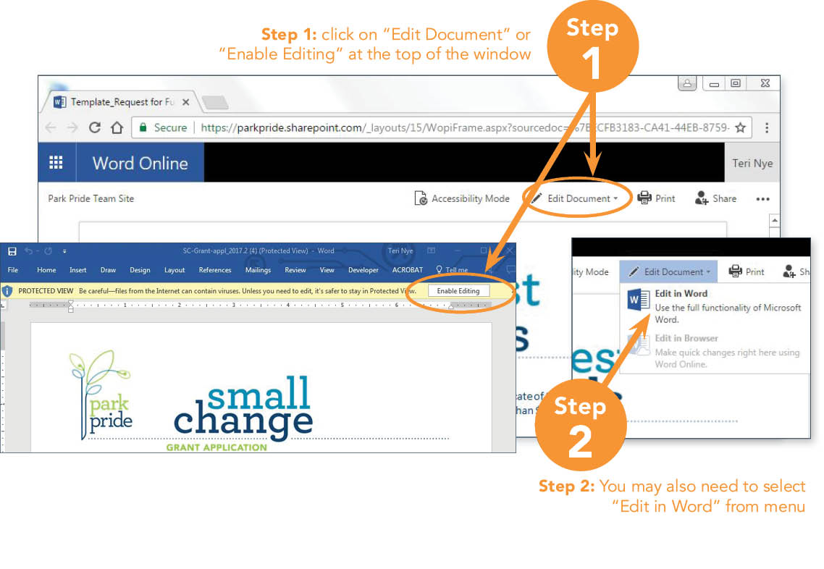

Application Checklist
- Application Form: Fill out all blanks on application form
- Budget Form: (included in this document) Use the Project Budget Guidelines to help you fill out the Project Budget Sheet. Include any quote, bids, or proposals. Include financial reports or letters of support documenting commitments for matching funds.
- Before Photo: Include 4-10 ‘before’ photos with a brief caption for each. Keep in mind that we will need ‘after’ photos from the same perspective/view at the completion of your project. In addition to including photos in your application, please send high resolution files (JPEG format, minimum 300dpi, 600+ preferred) via email to grants@parkpride.org.
- Planning Documents: Include all pertinent planning documents (Site plan, Master plan, Vision Plan, Renderings, Construction documents, Specification Documents, etc.). Examples of Park Vision Plans can be found at parkpride.org/get-involved/community-programs/park-visioning.
- 501c3 documentation: Include documentation of 501c3 status of your organization or fiscal partner (unless Park Pride is your fiscal partner).
- Letters of Support – Owner
Include a letter of support from the City of Atlanta Dept. of Parks & Recreation OR DeKalb County Dept. of Recreation, Parks & Cultural Affairs. Remember that ALL applicants must present their proposal to the City of Atlanta Dept. of Parks & Recreation OR to the DeKalb County Dept. of Recreation, Parks & Cultural Affairs before submitting a grant application.
- Letters of Support – Community Association
Include a letter of support from each community association whose jurisdiction includes or borders the park. Templates are on our website. Additional letters of support from police, NPU, etc. may be included as well.
- Additional Supporting Documents
Please email any additional supporting documents not listed above.

email | Send your completed grant application via email to: grants@parkpride.org with ‘Your Park’s Name_SC Application’ in the subject line. Attach the following:  (1) Application - combine all documents into a single PDF  (2) High Resolution Photos - high resolution files (JPEG format, minimum 300dpi, 600+ preferred).

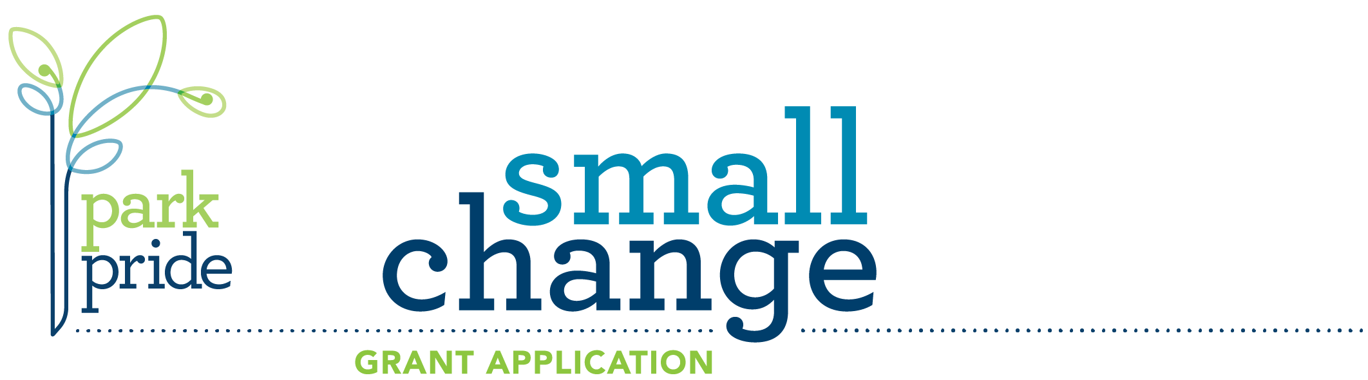
PARK INFORMATION
 | Park Name | Click here to enter text
 | Park Address | Click here to enter text
 | Park City | Click here to enter text |  | State | GA | Zip | enter
 | Friends of Park Name (required) |  | Click here to enter text

PRIMARY CONTACT
 | Name |  |  | Click here to enter text |  |  |  |  |  |  | Organization |  |  |  |  |  |  | Click here to enter text
 | Address |  |  | Click here to enter text |  |  |  |  |  |  | City/State/Zip |  |  |  |  |  |  | Click here to enter text
 | Phone |  |  | Click here to enter text |  |  |  |  |  |  | Email |  |  |  |  |  |  | Click here to enter text
SECONDARY CONTACT
 | Name |  |  | Click here to enter text |  |  |  |  |  |  | Organization |  |  |  |  |  |  | Click here to enter text
 | Address |  |  | Click here to enter text |  |  |  |  |  |  | City/State/Zip |  |  |  |  |  |  | Click here to enter text
 | Phone |  |  | Click here to enter text |  |  |  |  |  |  | Email |  |  |  |  |  |  | Click here to enter text
Financial Summary
Fill-in figures from your budget table on page 5 | Enter dollar amount |  |  |  |  | + |  | Enter dollar amount |  |  |  |  |  |  | = |  | Enter total budget here
 | Grant Request |  |  |  |  | + |  | Matching Funds |  |  |  |  |  |  | = |  | Total Project Budget
Park ownership
 |  | ☐ City of Brookhaven Park |  |  |  |  |  |  |  |  |  |  |  | ☐ City of Tucker Park
Click HERE for a list of City of Atlanta NPUs  Click HERE for a list of DeKalb Park Districts |  | ☐ City of Atlanta Park |  |  |  |  |  |  |  |  |  |  |  | ☐ DeKalb County Park
 |  | City of Atlanta NPU |  |  |  |  | Click here and choose. |  |  |  |  |  |  | Commissioner District |  |  |  |  |  | Click here and choose.
 |  | City Council Representative (below) |  |  |  |  |  |  |  |  |  |  |  | County Commissioner (below)
 |  |  | Click here to enter name |  |  |  |  |  |  |  |  |  |  |  |  | Click here to enter name
Check one | Does the organization applying for this grant have  ☐ 501c(3) status or ☐ Fiscal Partner account with Park Pride? ☐ Neither, need help
Office Use Only
Date Received |  |  |  |  | Approved |  |  |  |  | Declined |  |  | Deferred |  |  |  |  |  | Grant #

Project Summary
Briefly describe your project in 1 or 2 sentences.  EXAMPLE: “Replace  the aging playground with new equipment, grading and plantings.” | Click here to enter text
Project Description
Include  location detail, construction plans, materials detail or product specifications for amenities, who will perform the work and any other information pertaining to the project.  Please limit your description to  this page. | Click here to enter text

Project Value and impact
Briefly describe how your project is important and its impact on the park and surrounding community. | Click here to enter text
Project TimeLine
Include fundraising dates, construction dates with projected start, milestones, project completion, etc. | Click here to enter text

Maintenance Plan
Describe what maintenance is necessary and who will be responsible for each task. | Click here to enter text
Fundraising Plan
Provide details on how you plan to secure matching funds.  Complete your detailed budget on the following page. | Click here to enter text

Project Budget Guidelines

Expense Item

Be specific. List materials and product specifications. Include quotes, bids, and proposals as supporting documents.

Material items should include unit price and quantity under “expense item” (i.e. Bench [2 x $1,200] = $2,400).

Labor, professional services and project management should include # of hours and hourly rate.
(NOTE: Grant funds cannot be applied to project management services.)

Total Cost

Total cost of expense

Grant Request (list under Source of Funding)

Our grants require a minimum of a 1 to 1 match. You may not request a greater dollar amount than your matching funds. List your request from Park Pride under “Source of Funding” and list the amount of your request under “cash.”

Small Change Grant requests may be up to $2,500.

Community Building Grant requests may be from $3,000 to $50,000. First time Park Pride Grant recipients may request up to $10,000.

Legacy Grant requests may be from $50,000 to $100,000. First time Park Pride Grant recipients are not eligible for Legacy Grants.

Source of Funding

Matching funds are funds raised by the community to reach the 1:1 match.

Your matching funds must equal or exceed your request from Park Pride and be at least half of your total project budget.

Funds must be used for materials, labor, etc. directly related to the current project.

A portion of matching funds must be cash contributions from the community (from residents, local businesses, local fundraisers, etc., i.e., not from other grants, in-kind donations, or volunteer labor).

Cash refers to dollars raised. In-kind refers to materials, services, volunteer hours, etc.

Source of Matching Funds

Please be specific and describe sources of BOTH cash and in-kind donations for each expense listed.

Confirmed

Indicate matching funds are confirmed or not by typing a Y (yes) or N (no) in the right-hand column.

Project Budget TABLE
Step 1:  List each expense | Step 2:  List accurate estimates and under “Total Cost” | Step 3: Consult list of how grant funds can be used in instructions. | Step 5: Indicate the source, or expected source, of other funds and if the source is confirmed.
 |  | Step 4: Fill-in dollar amounts that will be paid by the grant and other funding sources.
Project Before Photos
Click on boxes at right to upload photos of the project site and/or any equipment or plantings that are being replaced, improved or repaired.
 |  | Type caption here |  | Type caption here
 |  | Type caption here |  | Type caption here
Application Checklist
Save application as either a MS Word  doc or a PDF.  Save letters of support as PDFs and attach to email  Email the file and  any attachments to grants@parkpride.org | Section/Documents
 | ☐ |  | All pages of application including budget table
 | ☐ |  | Before photos (insert photos into boxes above and type caption)
 | ☐ |  | Planning documents such as plats, surveys, cost estimates, designs
 | ☐ |  | 501(c)(3) documentation OR fiscal partner account verification
 | ☐ |  | Letters of support from property owner, either City of Atlanta or  Dekalb County
 | ☐ |  | Letters of support from all community associations surrounding the park

